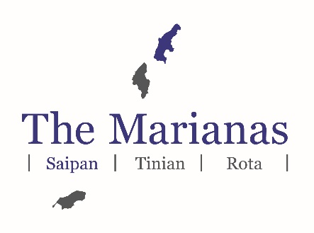

Saipan Marathon 2019

Race Categories
Full Marathon (26.2 miles/42.16 Kilometers)
Half Marathon (13.1 miles/21.08 Kilometers)
10K (6.2 miles)
Course: (Out and Back)

Date & Time
Saturday, March 9, 2019
*All races start and finish at Micro Beach, American Memorial Park, Garapan, Saipan
4:30 a.m. Full Marathon Start
5:30 a.m. Half Marathon Start
6:00 a.m. 10K Start

International Fees
Full Marathon (must be 16 years or older) $90.00
Half Marathon $60.00
10K $60.00

US and CNMI Fees
Full Marathon (must be 16 years or older) $55.00 (Picture ID or Passport Required)
Half Marathon/10K $45.00
Students $30.00 (Picture ID or Passport Required)

For US and CNMI Registrants Only:
Early Bird registration open till February 8, 2019.

To have your name included in the official Saipan Marathon booklet, participants must register by 5:00 p.m. (ChST), February 8, 2019. No exceptions.

February 9th - February 22nd Full Marathon $65.00
Half Marathon/10K $55.00
Students $40.00

February 23rd – March 6th Full Marathon $95.00
Half Marathon/10K $85.00
Students $55.00

Competition Rules
The course cut-off time for the Full Marathon is 8:30 a.m. (ChST) at the half-way point heading back. There is no cut-off time for Half Marathon and 10K. Participants who are unable to finish their respective race must return their timing chip to the race organizers or staff.

Race Packet Pick-Up Information
Friday, March 8, 2019, American Memorial Park Amphitheater, Garapan, Saipan
3:00 p.m. – 4:00 p.m. For team/group pick-up only
4:00 p.m. – 6:00 p.m. For individual pick-up only

All participants are required to pick-up their race packet during race packet pick-up hours on March 8. For team pick-up, one individual or team member must pick-up packets for those who have registered under one individual or team member during team pick-up time. Please make sure to pass out the race number to the correct person listed on the race bib. Marathon day morning pick up may be available for those who cannot pick-up their race packet on March 8. Plan to check-in at least one hour prior to the race start.
Receive your own Race Confirmation number with your assigned race bib number. Bring a printed copy of the Confirmation with you to pick-up your packet. Team Race Packet Pick-Up is available for those who made multiple entries online.

Other Notes:
- It is recommended for all participants to use Passport name for registering for the event.
- Once registered, A Confirmation Race Number (CRN) will be sent to you on your Email Address at the end of February 2019. If you haven’t received your (CRN) Please check your junk or spam folders. Please make sure your email address is correct.
- Bring a copy of your (CRN) with you to pick up your race packet.
- If you choose Team Pick Up, the team captain/ group leader/Tour Agents will be responsible for picking up and distributing all the race packets to the team members.
- Advanced packet pick up at 3-4 p.m. is strictly for Team Pick Up (groups of 10 or more). These are only for the participants who submitted there entries by the deadline on February 28th.
Banquet & Awards Ceremony
4:00 pm (venue to be announced at a later date)

Please bring your wristband which is included in your race-packet.
Awards will be presented to top six (6) overall men and women in for Full Marathon, Half Marathon and the 10K run. In addition, the 1st place finisher for Male and Female in each Age Division will receive an award.

Miscellaneous
- The MVA will not accept any entry forms or payments after 5 p.m. (ChST), Wednesday, March 6, 2019.
- Entry fee is nontransferable and nonrefundable. No change of race or cancellation will be accepted after March 6, 2019. All participants must submit entry forms with payment by the noted dates in order to be officially registered.
- Participants must register by February 8, 2019, to be included in the official Saipan Marathon booklet.
- Participants will receive a Finisher’s T-shirt, medal, certificate of completion and one (1) entry to the awards banquet. Additional awards banquet entries may be purchased at banquet venue.
- All courses have been certified by the Association of International Marathons and Distance Races (AIMS).
- All information published is subject to change or expire without notice. All runners bear sole responsibility of being informed of race rules and regulations.
- The Marianas Visitors Authority reserves the right to modify these terms and conditions at any time without prior notice at its sole discretion.

